**A**

**PROJECT REPORT**

**ON**

**bus pass management**

**SUBMITTED TO**

**SHIVAJI UNIVERSITY, KOLHAPUR**

**IN THE PARTIAL FULFILLMENT OF THE REQUIREMENT**

**FOR THE AWARD OF DEGREE**

**BACHELOR OF TECHNOLOGY IN COMPUTER SCIENCE AND ENGINEERING**

**SUBMITTED BY**

|  |  |  |
| --- | --- | --- |
| **MR.** | **Anuj Thombare** | **22UAD066** |

|  |  |  |
| --- | --- | --- |
| **MR.** | **Shreyansh Chougule** | **22UAD062** |

|  |  |  |  |
| --- | --- | --- | --- |
| **MR.** | **ADITYA KIRAN SUTAKE** | | **22UAD064** |
|  | |
|  |  | |  |
|  |  | |  |

**UNDER THE GUIDANCE OF**

**Mr. S. P. Pise**

 



**DEPARTMENT OF ARTIFICIAL INTELLIGENCE AND DATA SCIENCE ENGINEERING DKTE SOCIETY’S TEXTILE AND ENGINEERING INSTITUTE, ICHALKARANJI**

**(AN EMPOWERED AUTONOUMOUS INSTITUTE)**

**2024-2025**

**D.K.T.E. SOCIETY’S**

**TEXTILE AND ENGINEERING INSTITUTE, ICHALKARANJI**

**(AN EMPOWERED AUTONOUMOUS INSTITUTE)**

**DEPARTMENT OF ARTIFICIAL INTELLIGENCE AND DATA SCIENCE ENGINEERING**



**CERTIFICATE**

**This is to certify that, project work entitled**

**“<<PROJECT TITLE>>”**

**is a bonafide record of project work carried out in this college by**

|  |  |  |
| --- | --- | --- |
| **MR.** | **Anuj Thombare** | **22UAD066** |

|  |  |  |
| --- | --- | --- |
| **MR.** | **Shreyansh Chougule** | **22UAD062** |

|  |  |  |
| --- | --- | --- |
| **MR.** | **ADITYA KIRAN SUTAKE** | **22UAD064** |
|  |  |  |

**is in the partial fulfillment of award of degree Bachelor of Technology in Artificial Intelligence and Data Science Engineering prescribed by Shivaji University, Kolhapur for the academic year 2024-2025.**

**MR. S. P. PISE**

**(PROJECT GUIDE)**

**PROF. (DR.) T. I. BAGBAN PROF.(DR.) L.S.ADMUTHE**

**(HOD AI & DS DEPT.) (DIRECTOR)**

**EXAMINER: ________________**

**DECLARATION**

We hereby declare that, the project work report entitled “<< BUS PASS MANAGEMENT SYSTEM>>” which is being submitted to D.K.T.E. Society’s Textile and Engineering Institute Ichalkaranji, affiliated to Shivaji University, Kolhapur is in partial fulfillment of degree B.Tech.(AI & DS). It is a bonafide report of the work carried out by us. The material contained in this report has not been submitted to any university or institution for the award of any degree. Further, we declare that we have not violated any of the provisions under Copyright and Piracy / Cyber / IPR Act amended from time to time.

|  |  |  |  |
| --- | --- | --- | --- |
| **Title** | **Name of the Student** | **PRN** | **Signature** |
| **MR**    **MR.** | **Shreyansh chougule**  **Anuj Thombare** | **22UAD062**  **22UAD066** |  |
| MR. | ADITYA SUTAKE | 22UAD064 |  |
|  |  |  |  |
|  |  |  |  |

**ACKNOWLEDGEMENT**

With great pleasure we wish to express our deep sense of gratitude to Mr. S. P. Pise for his valuable guidance, support, and encouragement in the completion of this project report.

Also, we would like to take the opportunity to thank our head of department Dr. T. I. Bagban for his cooperation in preparing this project report.

We feel gratified to record our cordial thanks to other staff members of the Artificial Intelligence and Data Science Department for their support, help, and assistance which they extended as and when required.

Thank you,

|  |  |  |
| --- | --- | --- |
| **Title** | **Name of the Student** | **PRN** |
| MR  MR  MR. | ANUJ THOMBARE  SHREYANSH CHOUGULE  ADITYA SUTAKE | 22UAD066  22UAD062  22UAD064 |
|  |  |  |
|  |  |  |

**ABSTRACT**

The **Bus Pass Management System** is a software application designed to automate and streamline the process of issuing, renewing, and managing bus passes for commuters. Traditional methods of handling bus passes involve manual paperwork and long queues, leading to inefficiencies and user dissatisfaction. This project aims to digitize the entire system, providing a more convenient and efficient solution for both users and administrators.

The system allows users to apply for new passes, renew existing ones, and make payments online. Administrators can verify applications, manage user records, and generate reports with ease. The platform features user authentication, a secure payment gateway, real-time status tracking, and automated notifications. By reducing human intervention and paperwork, the system enhances operational efficiency and improves the overall user experience.

This project utilizes technologies such as HTML, CSS, JavaScript for the front end, and PHP/MySQL or similar frameworks for the back end. It is scalable, user-friendly, and designed with a focus on security and data integrity.

In conclusion, the Bus Pass Management System not only modernizes public transportation access but also contributes to a smarter, more digital infrastructure for urban mobility.

**INDEX**

1. **Introduction 1** 
   1. Problem definition
   2. Aim and objective of the project
   3. Scope and limitation of the project 2
2. **Background study and literature overview** 
   1. Literature overview
   2. Investigation of current project and related work
3. **Requirement analysis 3**

a. Requirement Gathering

b. Requirement Specification

c. Use case Diagram

1. **System design 4-6**
   1. Architectural Design
   2. Flow Chart
   3. System Modeling
      1. Dataflow Diagram
2. **Implementation 7**

a. Agile Methodologies

b. Development Model

1. **Future Scope 8**
2. **References (Public repository GitHub source code links) 9**

**1. Introduction**

**a. Problem Definition**

Public transport systems often rely on manual processes for issuing and managing bus passes, which can lead to inefficiencies such as long queues, delays, loss of records, and human errors. Users face inconvenience in applying for or renewing bus passes due to limited access points and time-consuming procedures. Additionally, administrative staff struggle with maintaining physical records and ensuring data accuracy. These issues call for an efficient, digital solution to manage bus passes more effectively.

**b. Aim and Objective of the Project**

**Aim:**  
To develop a digital Bus Pass Management System that automates the process of applying, renewing, and managing bus passes for users, while simplifying administrative tasks.

**Objectives:**

* To provide an easy-to-use platform for users to apply for new bus passes and renew existing ones online.
* To enable secure user registration, login, and profile management.
* To allow online submission of required documents and payment for bus passes.
* To help administrators review applications, approve or reject requests, and manage records.
* To generate reports for tracking usage, payments, and user statistics.
* To reduce paperwork, save time, and minimize errors through automation.

**c. Scope and Limitations of the Project**

**Scope:**

* The system caters to students, employees, and general passengers who need regular bus passes.
* Users can apply, renew, and track their pass status from any internet-enabled device.
* Admin dashboard allows monitoring of user requests, payment verification, and data management.
* Notifications (email/SMS) can be sent to users regarding approval, expiry, or renewal reminders.

**Limitations:**

* Internet access is required for users to access the system.
* The system does not cover ticketing for one-time bus rides.
* The platform may not support integration with third-party government databases without official APIs.
* Security and payment processing depend on the implementation of external gateways and encryption measures.
* Any hardware limitations (e.g., QR scanners for physical passes) are not handled by the software alone.

**2. Background study and literature overview**

**a. Literature Overview**

The evolution of digital systems in transportation has led to the development of various automated ticketing and pass management solutions across the world. Research shows that the integration of information and communication technology (ICT) in public transport significantly improves efficiency, user satisfaction, and data accuracy.

Several studies and case implementations have highlighted the importance of centralized management systems for bus passes. These systems often involve online application portals, secure user authentication, payment gateways, and database management. Technologies such as RFID, QR codes, and smart cards have been incorporated to support verification and validation processes.

Literature also indicates a shift toward mobile apps and web portals, emphasizing the need for responsive design, secure access, and real-time updates. Key challenges discussed include system scalability, user privacy, data security, and integration with existing government or transport authority databases.

**b. Investigation of Current Projects and Related Work**

A number of existing projects and real-world implementations have paved the way for digital bus pass systems. Some examples include:

* **Government Transport Portals** (e.g., BMTC in Bangalore, MTC in Chennai): These platforms provide online pass services for students and regular commuters. They have helped reduce congestion at bus depots and administrative offices.
* **University/College Transportation Systems**: Many institutions have adopted custom bus pass management software for students and faculty, allowing them to apply and renew passes via intranet portals.
* **Mobile Applications**: Apps like Moovit and m-Indicator (in India) provide integrated transport info, though their bus pass functionalities are limited or region-specific.
* **Smart Card Systems**: Cities like London (Oyster Card) and Singapore (EZ-Link) have adopted RFID-enabled cards for transport access, offering a seamless travel experience, although such systems are hardware-dependent and expensive to implement.

**3. Requirement analysis**

**a. Requirement Gathering**

Requirement gathering involves collecting functional and non-functional needs from users, administrators, and stakeholders to design the system effectively. This phase includes interviews, questionnaires, and research into existing systems.

**Key Stakeholders:**

* Bus passengers (students, employees, general public)
* System administrators
* Transport department officials

**Methods Used:**

* User interviews and surveys to identify challenges in the manual pass system
* Review of existing transport pass platforms
* Consultations with administrators for backend functionality needs

**Identified Needs:**

* Easy-to-use interface for applying/renewing bus passes
* Secure login and account management
* Online payment and document upload
* Admin tools for approval/rejection
* Notifications for status updates and renewals

**b. Requirement Specification**

This is typically divided into **Functional Requirements** and **Non-Functional Requirements**.

**Functional Requirements:**

* **User Registration/Login:** Passengers must be able to register and log in securely.
* **Apply for Pass:** Users can apply for a new pass by filling out a form and uploading necessary documents.
* **Renew Pass:** Users can renew expired or about-to-expire passes.
* **Online Payment:** Integration with a payment gateway for fee transactions.
* **Admin Dashboard:** Admins can view, approve, or reject applications.
* **Notification System:** Email/SMS alerts for approvals, expirations, and renewals.
* **Pass Generation:** Digital pass generation with a unique ID (optionally with QR code).

**Non-Functional Requirements:**

* **Usability:** User-friendly UI/UX for both users and administrators.
* **Performance:** The system should respond to user actions within 2 seconds.
* **Security:** Password encryption, secure login, and data validation.
* **Scalability:** Capable of handling a large number of users and requests.
* **Portability:** Accessible from desktops, laptops, and mobile devices.

**4. System design**

1. **a. Architectural Design**
2. The **Architectural Design** defines the overall structure of the system, how components interact, and how data flows between layers. A typical **3-tier architecture** works well for this project:
3. **1. Presentation Layer (Front-End):**
4. Responsible for user interaction
5. Technologies: HTML, CSS, JavaScript (React or plain JS)
6. Users: Applicants (students/general public) and Admin
7. **2. Application Layer (Back-End):**
8. Handles business logic, user request processing, and routing
9. Technologies: bootstrap .
10. Functions: Authentication, application processing, notifications
11. **3. Data Layer (Database):**
12. Stores all data: user profiles, pass details, payment records, application statuses
13. Technologies: MySQL

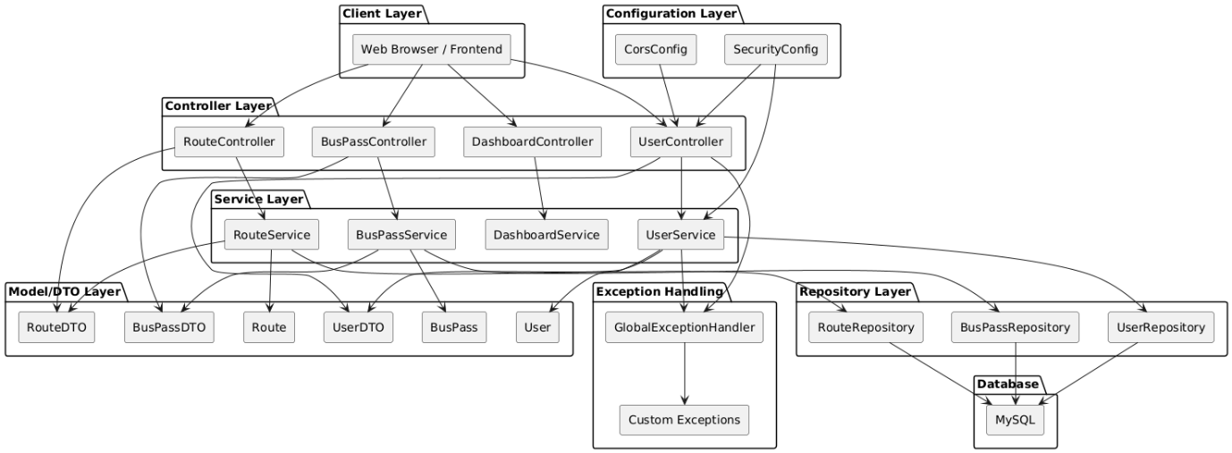

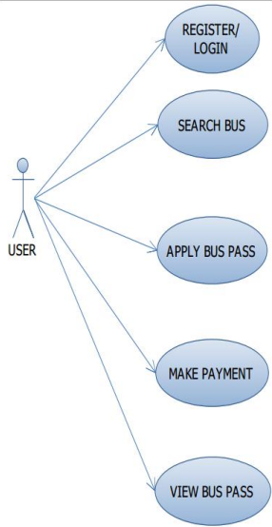

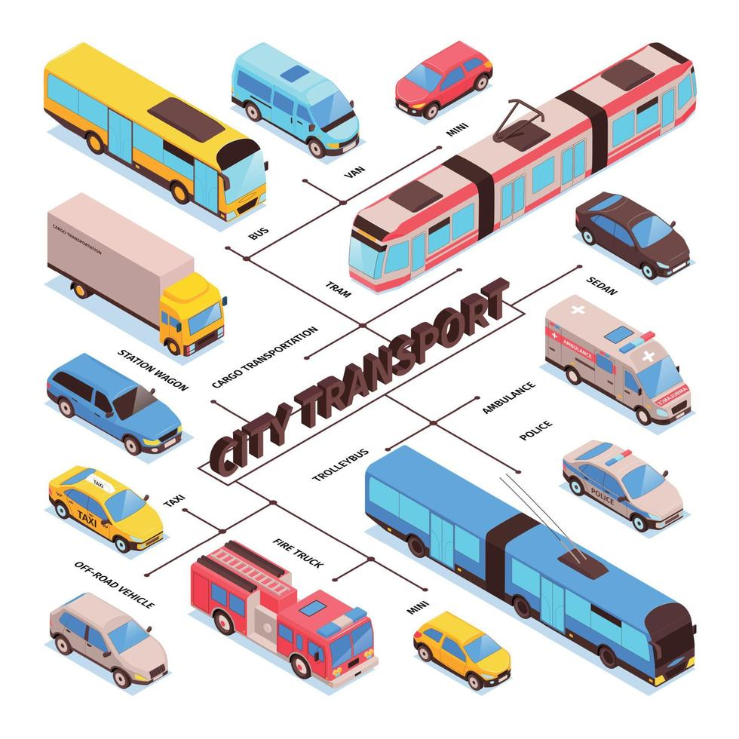

**b. Flow Chart**

Here’s a **high-level flow chart** for the Bus Pass Management System:

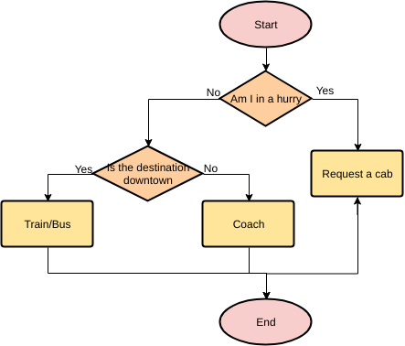

**5. Implementation**

**a. Agile Methodologies**

**Agile methodology** is an iterative and incremental approach to software development that emphasizes flexibility, customer feedback, and rapid delivery of functional software.

**Key Principles Applied:**

* **Iterative Development:** Features of the Bus Pass Management System (e.g., registration, pass application, admin dashboard) are developed in short sprints (1–2 weeks).
* **Customer Collaboration:** Feedback from users (students, passengers, transport staff) is gathered frequently and used to improve the system.
* **Working Software Over Documentation:** Focus is on delivering a working pass system quickly rather than waiting until everything is perfect.
* **Responding to Change:** If new requirements or issues arise (like adding QR codes or mobile support), they can be adapted in the next sprint.

**Agile Practices Used:**

* **Daily Stand-ups:** Team members discuss progress and blockers.
* **Sprint Planning:** Features are broken down into user stories and planned over multiple sprints.
* **Demo & Review:** After each sprint, a functional part of the system is shown to stakeholders.
* **Retrospective:** The team discusses what went well and what can be improved in the next cycle.

**b. Development Model**

For this project, the **Agile Incremental Model** is the most suitable development model.

**Why Agile Incremental?**

* It allows building the system **in parts (increments)**, starting from core features like user registration and login, and gradually adding features like payment and pass status tracking.
* Each increment delivers a **usable product**.
* Bugs and feedback can be addressed **immediately** in the next iteration.
* It supports **continuous improvement**, especially important for a system meant to serve real users.

**Incremental Development Stages:**

| **Increment** | **Features Developed** |
| --- | --- |
| Increment 1 | User Registration, Login, Basic UI |
| Increment 2 | Apply/Renew Pass Form, Document Upload |
| Increment 3 | Payment Gateway Integration |
| Increment 4 | Admin Dashboard, Approve/Reject Applications |
| Increment 5 | Notification System, Digital Pass Generation |
| Increment 6 | Reports Module, Security Enhancements, Bug Fixes |

**6. Future Scope**

**1. Mobile Application Integration**

* **Developing a dedicated mobile app for Android and iOS to make the system more accessible on the go.**
* **Features like push notifications, GPS tracking, and QR code scanning can improve user experience.**

**2. QR Code and NFC-based Pass Validation**

* **Implementing QR codes or NFC (Near Field Communication) technology for digital pass validation, reducing the need for physical cards.**
* **Conductors can use a scanner or mobile device to verify pass authenticity.**

**3. Integration with Government Databases**

* **Connecting the system with official databases (e.g., Aadhar, student IDs) for easier verification and reduced fraud.**
* **Automatic eligibility checks for discounted or subsidized passes.**

**4. AI-based Analytics and Reporting**

* **Using machine learning to analyze usage trends, peak times, and fraud detection.**
* **Helping transport authorities make data-driven decisions for better service planning.**

**5. Multilingual and Accessibility Support**

* **Adding multi-language support for users from different regions.**
* **Ensuring the platform is fully accessible to users with disabilities.**

**6. Support for Multiple Transport Modes**

* **Extending the system to cover metro, local trains, and ferries, creating a unified pass system for all public transport.**
* **Integration with smart cards or digital wallets for seamless payments.**

**7. Chatbot and Customer Support**

* **Adding a chatbot to assist users with queries related to applications, payments, and pass status in real-time.**

**8. Blockchain for Pass Verification**

* **In the long term, blockchain can be explored for tamper-proof records and decentralized validation of pass data.**

**7. References (public repository GitHub source code links)**

* **Bus Pass Management System – IRJMETS**
* **The system aims to enhance efficiency by reducing manual processes and ensuring accurate record-keeping.**
* **Smart Bus Pass System – ResearchGate**
* **User interface: https://github.com/Aditya09adi/bus-pass-**